Day47&48 - Task25 - Jenkins(Part-4)

Task-1: Setup Jenkins CICD pipeline using freestyle job using Docker containers using below code.

Step 1: Check Jenkins server capacity
- Connect to Jenkins01 through Git Bash:
- ssh -i your-key.pem ec2-user@<JENKINS-PUBLIC-IP>
- Run:
- free -h
- df -h
- java -version
- git --version
- docker --version
- sudo systemctl status docker --no-pager
For Jenkins + Docker builds, Nexus and Tomcat, I recommend at least:
- Instance: t3.medium
- RAM: 4 GB
- Storage: 20–30 GB
- Security-group access restricted to your IP wherever possible
A t3.small may run out of memory when Nexus and Maven builds run together.

Step 2: Install Docker if unavailable
- For Amazon Linux 2023:
- sudo dnf update -y
- sudo dnf install docker -y
- sudo systemctl enable --now docker
- sudo usermod -aG docker ec2-user
- sudo usermod -aG docker jenkins
- Restart Jenkins:
- sudo systemctl restart jenkins
- Log out and reconnect so the ec2-user group membership is refreshed:
- exit
- After reconnecting, verify:
- docker version
- id jenkins
- sudo -u jenkins docker ps
The last command must work without a permission-denied error.
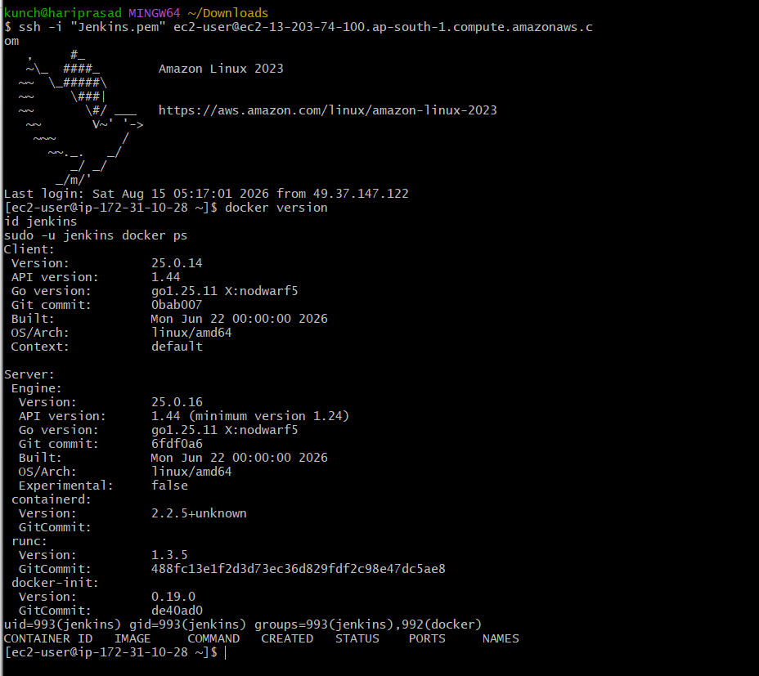

Step 3: Test the Maven Docker container
Run:
- docker run --rm maven:3.9-eclipse-temurin-17 mvn -version
- Then test the project manually:
- mkdir -p ~/task1-test
- cd ~/task1-test
- git clone https://github.com/betawins/hiring-app.git
- cd hiring-app
- ls -la
- find . -maxdepth 2 -name pom.xml -o -name Dockerfile
- Build it inside Maven’s container:
- docker run --rm \
- -v "$PWD:/app" \
- -v maven-cache:/root/.m2 \
- -w /app \
- maven:3.9-eclipse-temurin-17 \
- mvn clean package -DskipTests
Check the generated artifact:
- find . -path "*/target/*" \( -name "*.war" -o -name "*.jar" \)
- Send me the outputs of:
- free -h
- docker version
- sudo -u jenkins docker ps
- find . -maxdepth 2 -name pom.xml -o -name Dockerfile
- find . -path "*/target/*" \( -name "*.war" -o -name "*.jar" \)
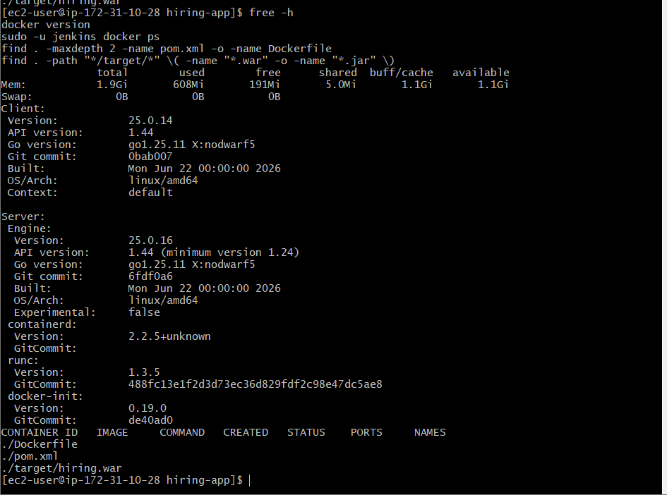

Important resource issue
Your Jenkins server has only 2 GB RAM and no swap:
Mem: 1.9 GiB
Swap: 0 B
Running Jenkins, Maven builds, Nexus and Tomcat together may cause an out-of-memory failure. Resize Jenkins01 from t3.small to t3.medium before continuing.
Resize EC2
- EC2 Console → Instances → select Jenkins01
- Stop instance
- Actions → Instance settings → Change instance type
- Select t3.medium
- Start instance
- Confirm Jenkins is running:
- free -h
- sudo systemctl status jenkins --no-pager
- sudo systemctl status docker --no-pager
- Add 2 GB swap
Even with t3.medium, swap provides protection during Maven and Nexus activity:
- sudo dd if=/dev/zero of=/swapfile bs=1M count=2048
- sudo chmod 600 /swapfile
- sudo mkswap /swapfile
- sudo swapon /swapfile
- Make it permanent:
- echo '/swapfile swap swap defaults 0 0' | sudo tee -a /etc/fstab
Verify:
- free -h
- swapon --show
- Expected result:
- Mem: approximately 3.8 GiB
- Swap: 2.0 GiB
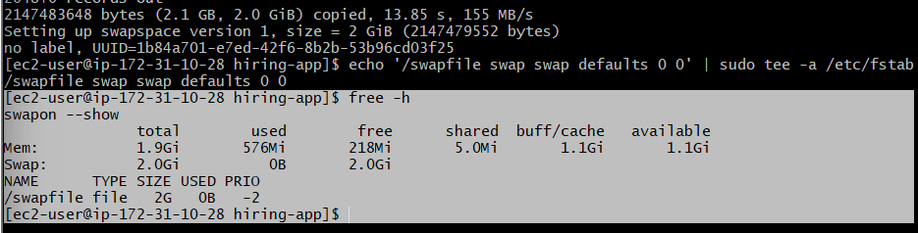
Do this first. After verification, our next step is launching Nexus as a Docker container on port 8082:
- Jenkins: 8081
- Nexus: 8082
- Tomcat: 8080
- Sonar: 9000

Step 4: Start Nexus Repository
Run on the Jenkins server:
- docker volume create nexus-data
- Start Nexus on host port 8082 with limited memory:
- docker run -d \
--name nexus \
--restart unless-stopped \
-p 8082:8081 \
-v nexus-data:/nexus-data \
-e INSTALL4J_ADD_VM_PARAMS="-Xms512m -Xmx768m -XX:MaxDirectMemorySize=512m -Djava.util.prefs.userRoot=/nexus-data/javaprefs" \
--memory=1100m \
--memory-swap=1800m \
sonatype/nexus3:latest
Check status:
- docker ps
- docker stats --no-stream nexus
- docker logs --tail 50 nexus
- Nexus may require 2–5 minutes to start. Check until this appears:
- Started Sonatype Nexus
- Use:
- docker logs nexus 2>&1 | grep -i "Started Sonatype Nexus"
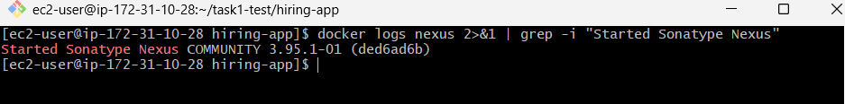
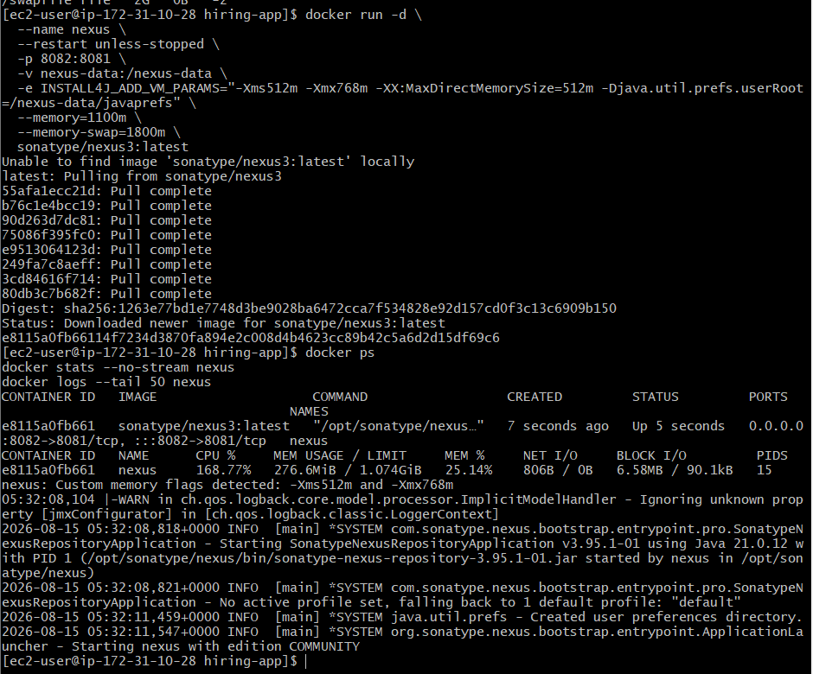
Open port 8082
In Jenkins01 security group, add:
Type | Port | Source
Custom TCP | 8082 | My IP

Open:
http://<JENKINS-PUBLIC-IP>:8082
Get the Nexus administrator password
docker exec nexus cat /nexus-data/admin.password
Log in with:
Username: admin
Password: output from the command
Complete the setup wizard:
- Enter the initial password.
- Set a new administrator password.
- Select Disable anonymous access.
- Finish.
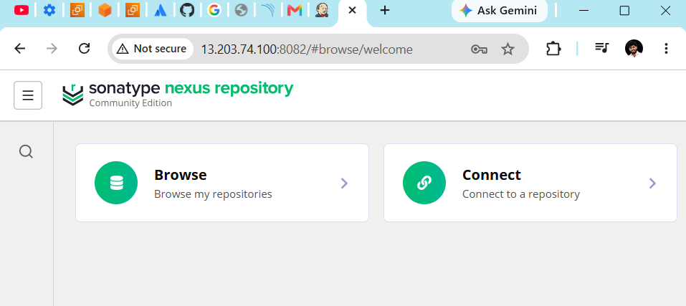
Create the Maven repository
In Nexus:
- Click the gear icon: Server administration
- Select Repositories
- Click Create repository
- Select maven2 (hosted)
- Configure:
Name: hiring-releases
Version policy: Release
Layout policy: Strict
Deployment policy: Allow redeploy
- Click Create repository.
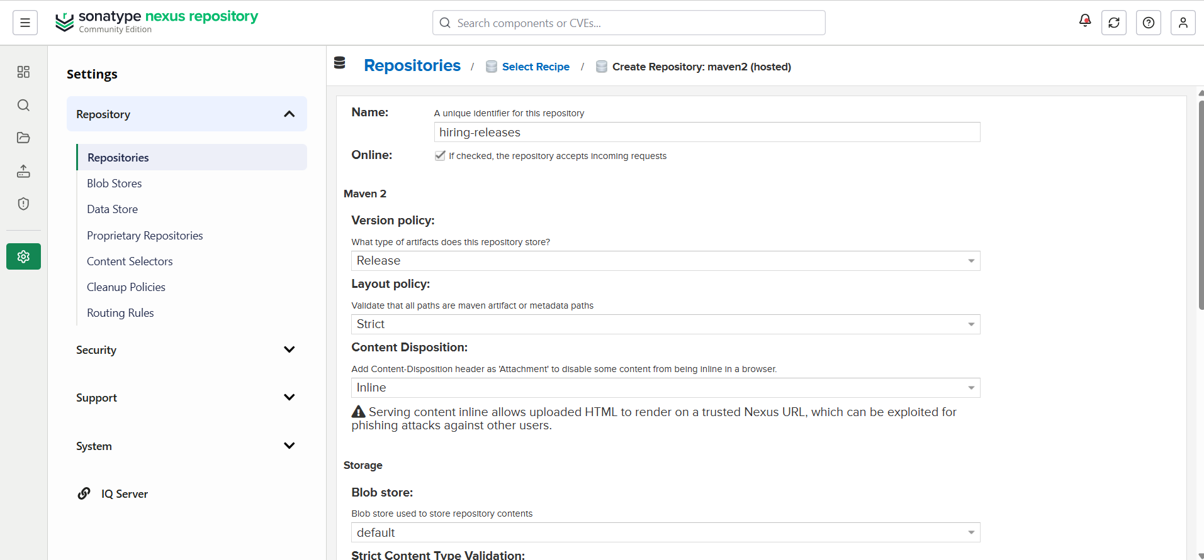
The upload URL will be:
http://<JENKINS-PRIVATE-IP>:8082/repository/hiring-releases/
Because Nexus and Jenkins are on the same server, Jenkins can use:
http://localhost:8082/repository/hiring-releases/

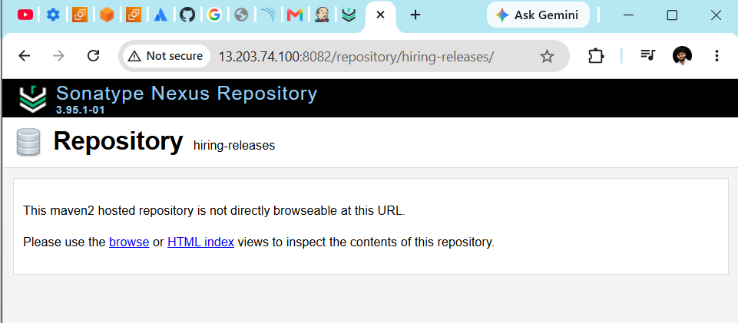
Verify Nexus locally:
- curl -I http://localhost:8082
- docker ps --filter name=nexus
- If the Nexus container shows Exited, run:
- docker logs --tail 100 nexus
- free -h
Once the Nexus page opens and hiring-releases is created
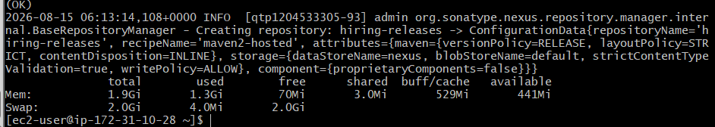
Test uploading the WAR file to Nexus
- Browse → hiring-releases → com → betawins → hiring → 1.0
- You should see:
- Hiring-1.0.war
- If you receive 403 Forbidden, the jenkins-hiring-role is missing the add or edit privilege. If you receive 401 Unauthorized, verify the username/password and ensure the user status is Active.

1. Confirm the role exists
- Open Security → Roles and check for:
- jenkins-hiring-role
- If missing, click Create role → Nexus role and configure:
- Role ID: jenkins-hiring-role
- Role name: Jenkins Hiring Role
- Add these privileges:
- nx-repository-view-maven2-hiring-releases-add
- nx-repository-view-maven2-hiring-releases-browse
- nx-repository-view-maven2-hiring-releases-edit
- nx-repository-view-maven2-hiring-releases-read
- Save the role.
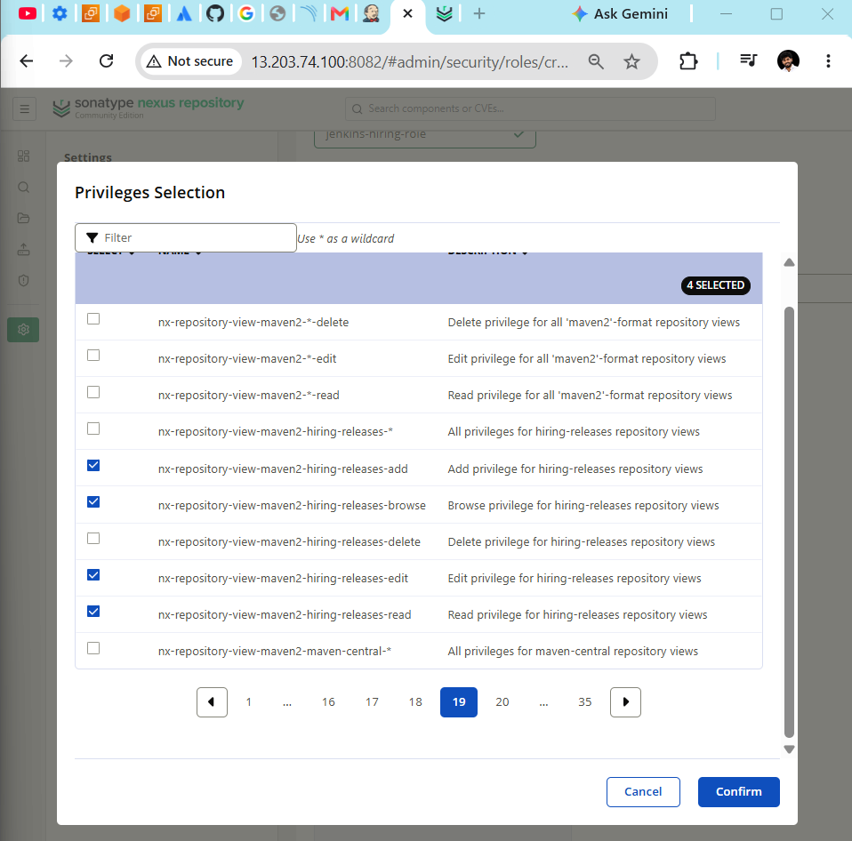

2. Create the user
- Return to Security → Users and click Create local user.
- Enter:
- User ID: jenkins
- First name: Jenkins
- Last name: CI
- Email: your email
- Password: create a new strong password
- Status: Active
- Under Roles, grant:
- jenkins-hiring-role
- Click Create local user.
- The Users page should then show:
- admin
- anonymous
- Jenkins
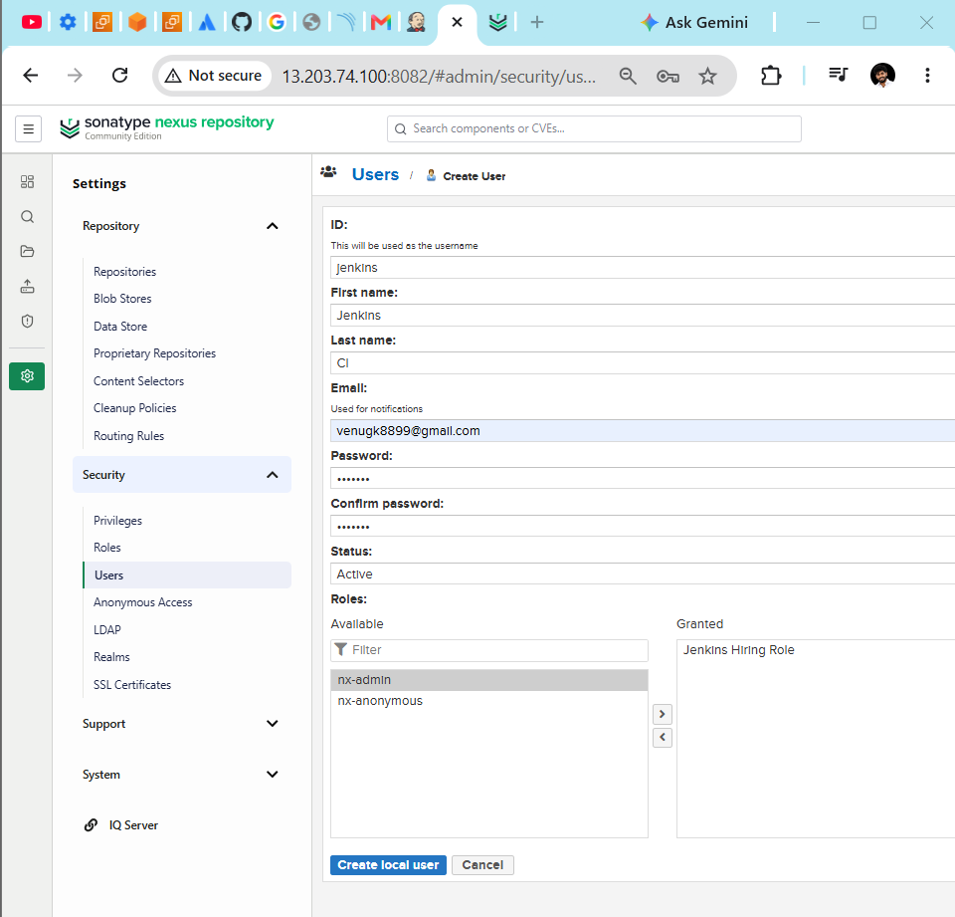
3. Retest
- curl -sS \
-u jenkins \
--upload-file target/hiring.war \
-o /dev/null \
-w "HTTP status: %{http_code}\n" \
http://localhost:8082/repository/hiring-releases/com/betawins/hiring/1.0/hiring-1.0.war
- Enter the newly created password. Expected result:
HTTP status: 201
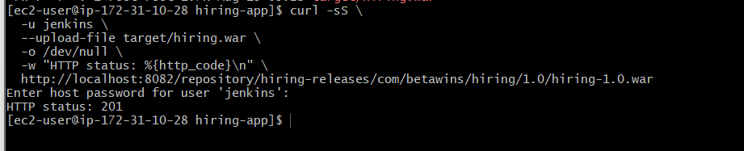

Start Tomcat in Docker
We’ll use Tomcat 9 because older Maven web applications commonly use javax.servlet; Tomcat 10+ requires the newer jakarta.* namespace.

Run:
- docker volume create tomcat-webapps
- Start Tomcat:
- docker run -d \
--name hiring-tomcat \
--restart unless-stopped \
-p 8080:8080 \
-v tomcat-webapps:/usr/local/tomcat/webapps \
--memory=512m -- memory-swap=768m \
tomcat:9.0-jdk17-temurin
- The official image initially keeps the default applications in webapps.dist. Copy them into the mounted webapps directory:
- docker exec hiring-tomcat \
- sh -c 'cp -a webapps.dist/. webapps/'
Restart Tomcat:
- docker restart hiring-tomcat
- Verify:
- docker ps --filter name=hiring-tomcat
- curl -I http://localhost:8080
- docker logs --tail 30 hiring-tomcat
Expected:
HTTP/1.1 200
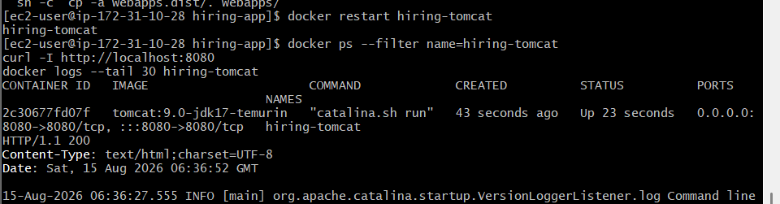
Open Tomcat in the browser
Add this inbound rule to the Jenkins EC2 security group:
Type | Port | Source
Custom TCP | 8080 | My IP
Open:
http://13.203.74.100:8080
You should see the Apache Tomcat home page.
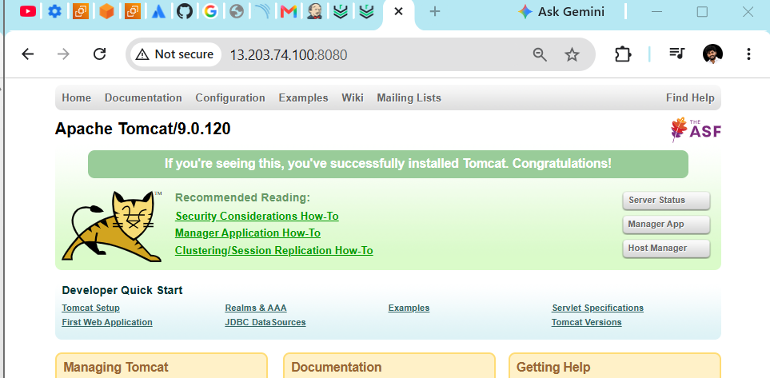

1. Create the Tomcat deployment user
Run:
- read -s -p "Enter a strong Tomcat deployment password: " TOMCAT_DEPLOY_PASSWORD
- echo
Add the user securely:
- docker exec \
- -e TOMCAT_DEPLOY_PASSWORD="$TOMCAT_DEPLOY_PASSWORD" \
- hiring-tomcat sh -c \
- 'sed -i "/<\/tomcat-users>/i\
- <role rolename=\"manager-script\"/>\
- <user username=\"jenkins-deployer\" password=\"$TOMCAT_DEPLOY_PASSWORD\" roles=\"manager-script\"/>" \
- conf/tomcat-users.xml'
Clear the shell variable:
- unset TOMCAT_DEPLOY_PASSWORD
2. Permit deployment from the Docker host
Tomcat Manager normally allows only connections originating inside the container. Permit access through the EC2/Docker host:
- docker exec hiring-tomcat \
- sed -i '/RemoteAddrValve/,+1 s/allow="[^"]*"/allow=".*"/' \
- webapps/manager/META-INF/context.xml
- Keep EC2 port 8080 restricted to My IP, not 0.0.0.0/0.
Restart:
- docker restart hiring-tomcat
3. Test Tomcat Manager
- curl -sS -u jenkins-deployer \
- http://localhost:8080/manager/text/list
Enter the new password.

4. Test WAR deployment
From the hiring-app directory:
- curl -sS -u jenkins-deployer \
--upload-file target/hiring.war \
"http://localhost:8080/manager/text/deploy?path=/hiring&update=true"
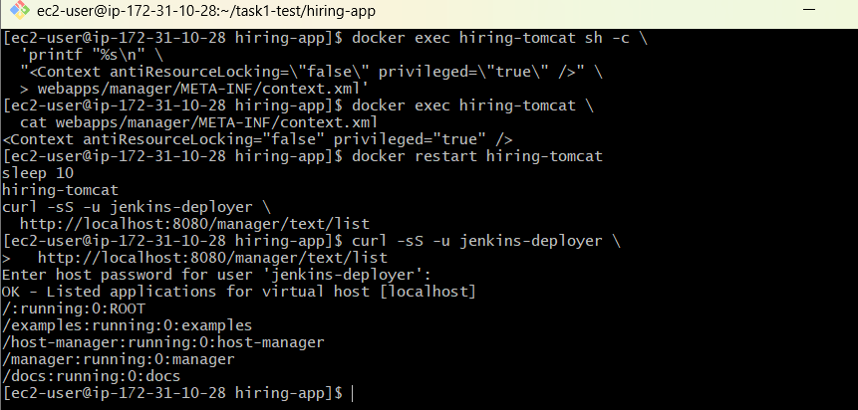
Verify:
- curl -I http://localhost:8080/hiring/
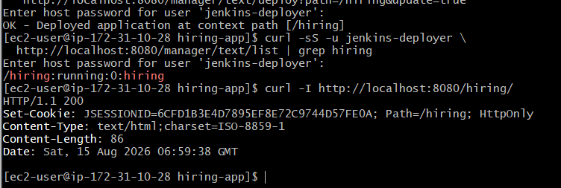
Open:
- http://13.203.74.100:8080/hiring/
- After successful deployment, add these credentials to Jenkins:
- Kind: Username with password
- Username: jenkins-deployer
- ID: tomcat-deploy-credentials
- Description: Tomcat deployment credentials

Next: Add Tomcat credentials to Jenkins
Open:
- http://13.203.74.100:8081
- Navigate to:
- Manage Jenkins → Credentials → System → Global credentials → Add Credentials
- Configure:
- Kind: Username with password
- Scope: Global
- Username: jenkins-deployer
- Password: your Tomcat deployment password
- ID: tomcat-deploy-credentials
- Description: Tomcat Docker deployment credentials
- Click Create.
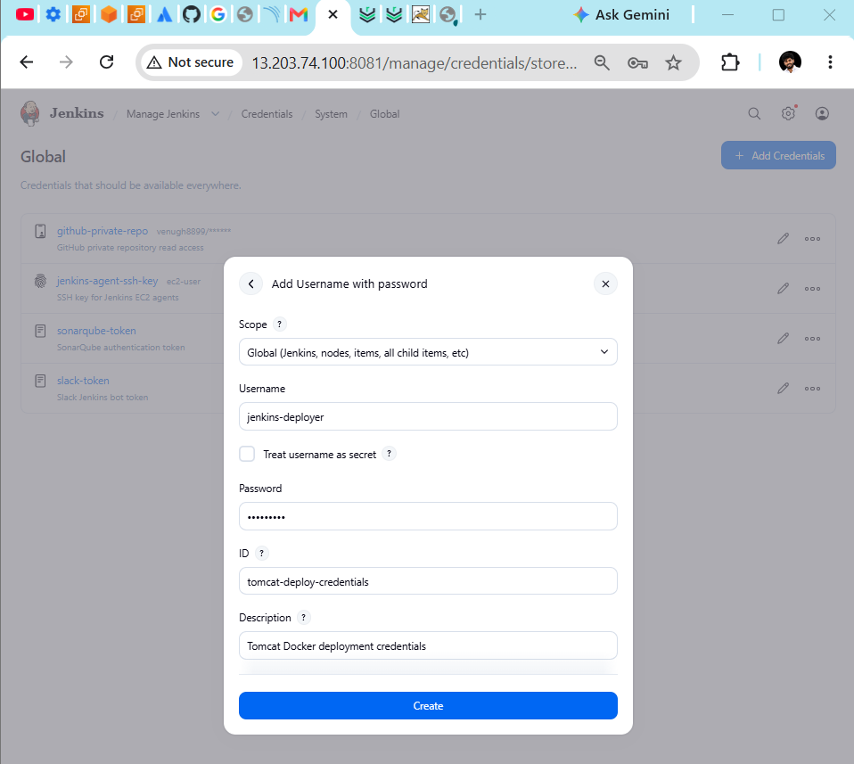
Also confirm these credentials exist:
Credential | Kind | ID
Nexus Jenkins user | Username with password | nexus-hiring-credentials
Tomcat deployment user | Username with password | tomcat-deploy-credentials
SonarQube token | Secret text | Existing Sonar token ID
Slack bot token | Secret text | Existing Slack credential
Verify required Jenkins plugins
Go to Manage Jenkins → Plugins → Installed plugins and search for:
- Git
- Credentials Binding
- SonarQube Scanner
- Slack Notification
- Workspace Cleanup
We can perform Nexus upload and Tomcat deployment with curl, so the Nexus Artifact Uploader and Deploy to Container plugins are optional.
After confirming credentials and plugins, create:
- New Item
- Name: 01-Hiring-App-Freestyle-CICD
- Type: Freestyle project

- Configure Git checkout and Docker Maven build
Open the Freestyle job:
- 01-Hiring-App-Freestyle-CICD → Configure
- 1. General
- Add description:
- Freestyle CI/CD job for hiring-app using Docker, SonarQube, Nexus, Slack and Tomcat.
- Optionally enable:
- Discard old builds
- Days to keep builds: 7
- Max builds to keep: 10
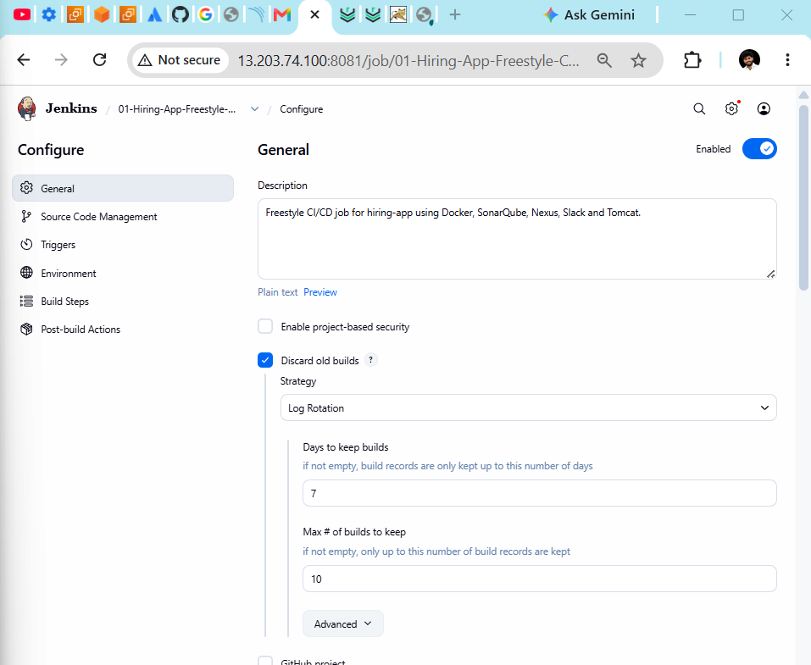
2. Source Code Management
Select Git:
- Repository URL: https://github.com/betawins/hiring-app.git
- Because it is public
- Credentials: None
- Check the repository’s branch from the server: git -C /home/ec2-user/task1-test/hiring-app branch --show-current
Use the returned branch in Jenkins: */main

3. Add Docker Maven build step
Under Build Steps → Add build step → Execute shell, paste:
- #!/bin/bash
set -e

echo "========== MAVEN COMPILATION AND PACKAGE =========="

mkdir -p "$WORKSPACE/.m2"

docker run --rm \
--user "$(id -u):$(id -g)" \
-e MAVEN_CONFIG=/tmp/.m2 \
-v "$WORKSPACE:/workspace" \
-v "$WORKSPACE/.m2:/tmp/.m2" \
-w /workspace \
maven:3.9-eclipse-temurin-17 \
mvn clean package -DskipTests

echo "========== VERIFY WAR =========="

test -f "$WORKSPACE/target/hiring.war"
ls -lh "$WORKSPACE/target/hiring.war"
4. Archive the WAR
Under Post-build Actions → Archive the artifacts, enter: target/hiring.war
Enable: Archive artifacts only if build is successful

5. Save and test
Click: Save → Build Now
Open Build History → latest build → Console Output.
Expected ending:
BUILD SUCCESS
target/hiring.war
Finished: SUCCESS
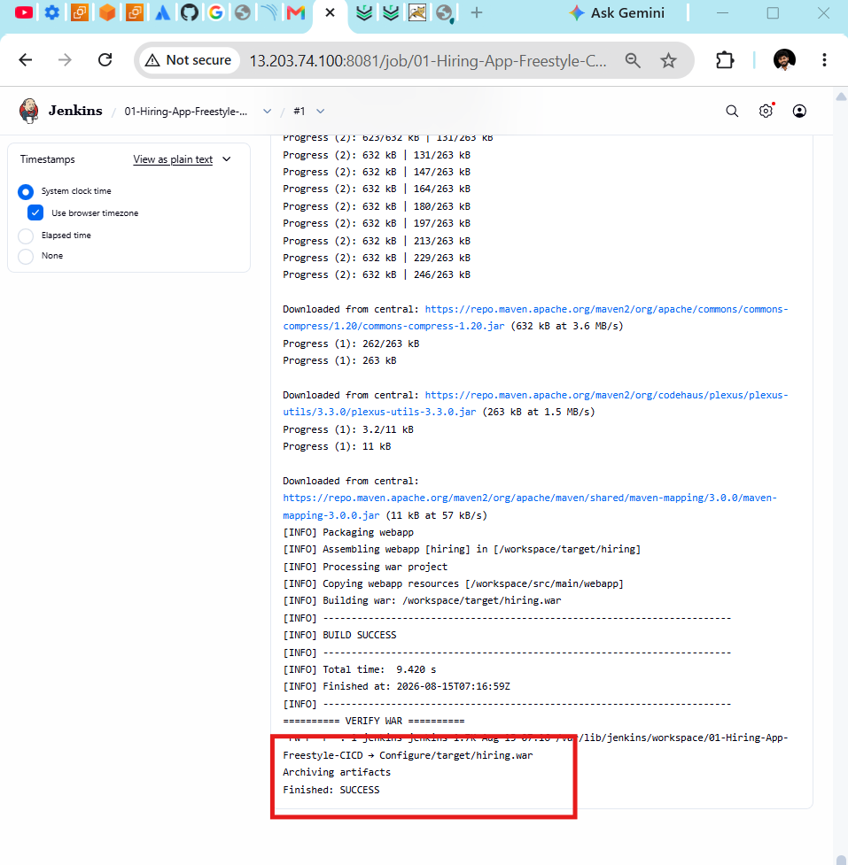

Although the assignment lists SonarQube before Maven compilation, Java analysis normally needs
compiled bytecode. The reliable technical order is:
Git checkout → Maven compile/package → SonarQube → Nexus → Tomcat → Slack

SonarQube integration
1. Bind the SonarQube token
- Open: 01-Hiring-App-Freestyle-CICD → Configure
- Under Environment, enable: Use secret text(s) or file(s)
- Click: Add → Secret text
- Configure:
- Variable: SONAR_TOKEN
- Credentials: select your existing SonarQube token
- Do not enter the token directly in the shell script.
2. Add SonarQube build step
Under Build Steps, click: Add build step → Execute shell
Place this second build step after Maven compilation:
- #!/bin/bash
set -e

echo "========== SONARQUBE ANALYSIS =========="

mkdir -p "$WORKSPACE/.m2" "$WORKSPACE/.sonar"

docker run --rm \
--user "$(id -u):$(id -g)" \
-e HOME=/tmp \
-e SONAR_USER_HOME=/tmp/.sonar \
-e SONAR_TOKEN="$SONAR_TOKEN" \
-v "$WORKSPACE:/workspace" \
-v "$WORKSPACE/.m2:/tmp/.m2" \
-v "$WORKSPACE/.sonar:/tmp/.sonar" \
-w /workspace \
maven:3.9-eclipse-temurin-17 \
sh -c 'mvn \
-Dmaven.repo.local=/tmp/.m2/repository \
org.sonarsource.scanner.maven:sonar-maven-plugin:sonar \
-Dsonar.projectKey=hiring-app \
-Dsonar.projectName=Hiring-App \
-Dsonar.host.url=http://172.31.0.163:9000 \
-Dsonar.token="$SONAR_TOKEN" \
-Dsonar.java.binaries=target/classes'

echo "========== SONARQUBE ANALYSIS COMPLETED =========="
The order should now be:
- Build step 1: Maven compilation/package
- Build step 2: SonarQube analysis
- Post-build: Archive target/hiring.war

3. Save and test
Click: Save → Build Now
In Console Output, expected SonarQube messages include: ANALYSIS SUCCESSFUL
Dashboard: http://172.31.0.163:9000/dashboard?id=hiring-app
Finished: SUCCESS
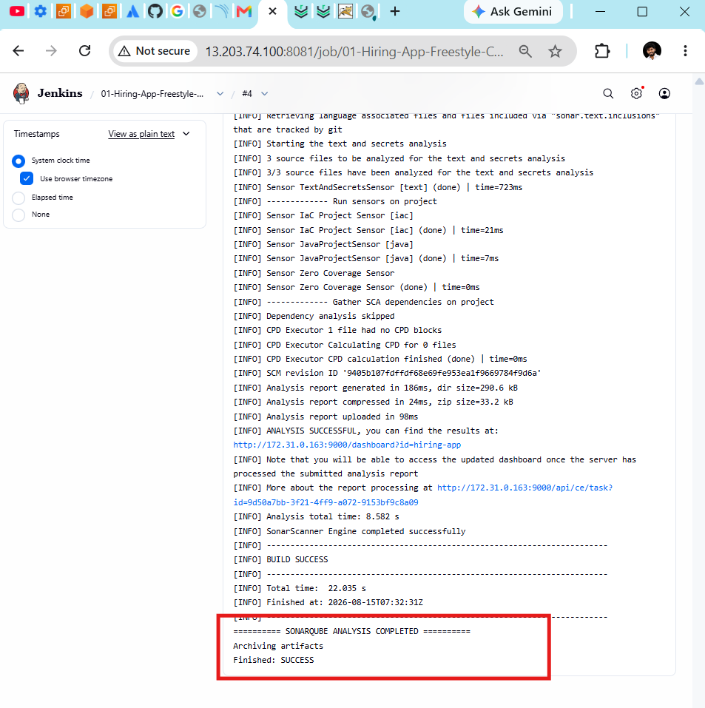
Upload Jenkins artifact to Nexus

1. Bind Nexus credentials
- Open: 01-Hiring-App-Freestyle-CICD → Configure → Environment
- Inside Use secret text(s) or file(s), click: Add → Username and password (separated)
- Configure:
- Username Variable: NEXUS_USER
- Password Variable: NEXUS_PASSWORD
- Credentials: nexus-hiring-credentials
- Keep the existing SONAR_TOKEN binding.
2. Add the Nexus build step
Under Build Steps, add another Execute shell after SonarQube:
- #!/bin/bash
set -e

echo "========== NEXUS ARTIFACT UPLOAD =========="

ARTIFACT_VERSION="1.0.${BUILD_NUMBER}"
ARTIFACT_NAME="hiring-${ARTIFACT_VERSION}.war"

NEXUS_PATH="http://localhost:8082/repository/hiring-releases/com/betawins/hiring/${ARTIFACT_VERSION}/${ARTIFACT_NAME}"

HTTP_STATUS=$(curl -sS \
-u "${NEXUS_USER}:${NEXUS_PASSWORD}" \
--upload-file "$WORKSPACE/target/hiring.war" \
-o /dev/null \
-w "%{http_code}" \
"$NEXUS_PATH")

echo "Nexus upload HTTP status: ${HTTP_STATUS}"
echo "Artifact: ${NEXUS_PATH}"

if [ "$HTTP_STATUS" != "201" ]; then
echo "Nexus upload failed"
exit 1
fi

echo "========== NEXUS UPLOAD SUCCESSFUL =========="
3. Current build-step order
1. Maven compilation/package
2. SonarQube analysis
3. Nexus artifact upload
4. Archive target/hiring.war
Save and click Build Now.
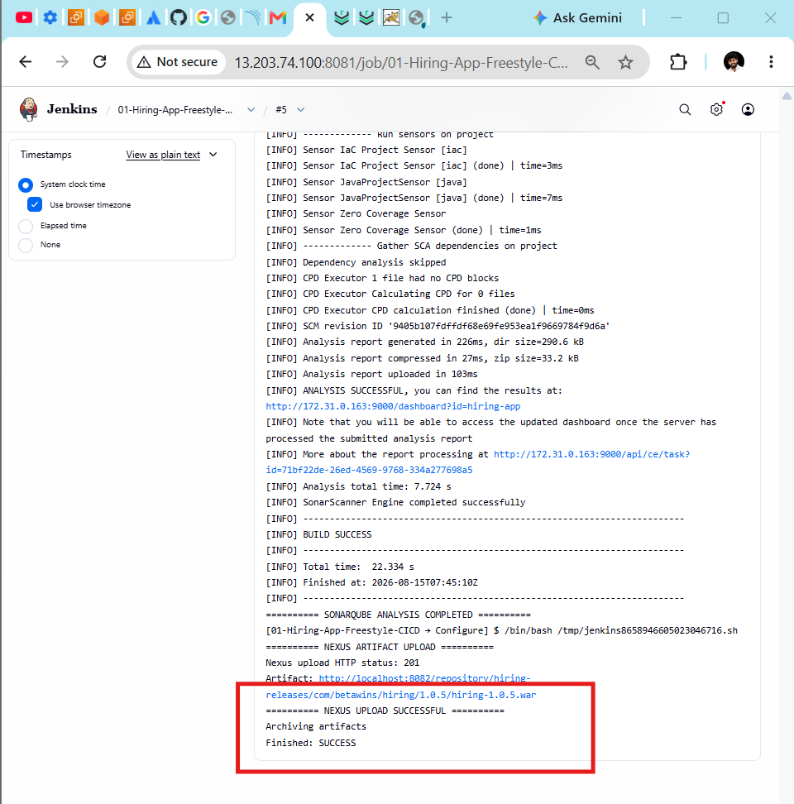

In Nexus, browse:
hiring-releases
└── com/betawins/hiring/1.0.<build-number>/
└── hiring-1.0.<build-number>.war
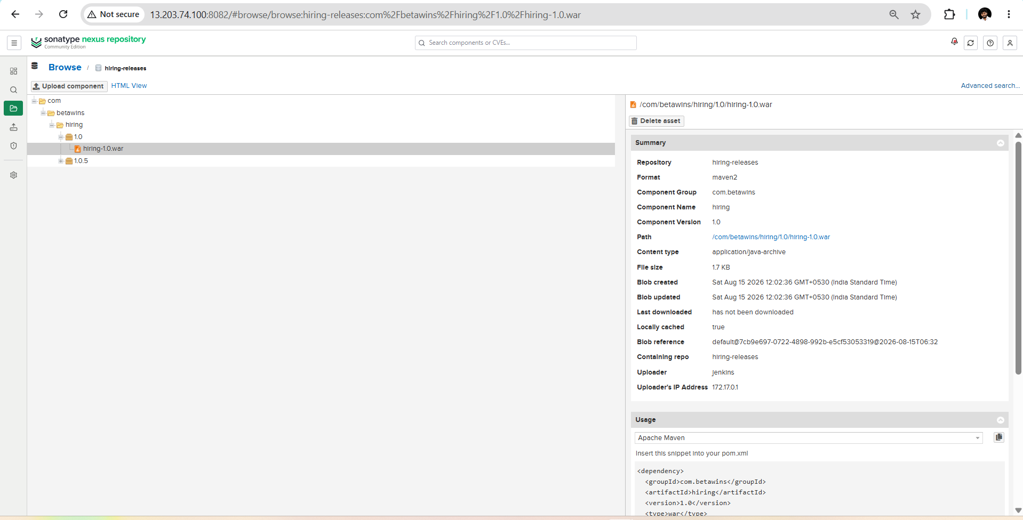

Next: Deploy to Tomcat from Jenkins
1. Bind Tomcat credentials
- In the Freestyle job: Configure → Environment → Use secret text(s) or file(s)
- Click: Add → Username and password (separated)
- Configure: Username Variable: TOMCAT_USER
- Password Variable: TOMCAT_PASSWORD
- Credentials: jenkins-deployer/******
- (Tomcat Docker deployment credentials)
2. Add Tomcat deployment step
Under Build Steps, add another Execute shell after the Nexus upload:
- #!/bin/bash
set -e

echo "========== DEPLOY TO TOMCAT =========="

DEPLOY_RESPONSE=$(curl -sS \
-u "${TOMCAT_USER}:${TOMCAT_PASSWORD}" \
--upload-file "$WORKSPACE/target/hiring.war" \
"http://localhost:8080/manager/text/deploy?path=/hiring&update=true")

echo "$DEPLOY_RESPONSE"

if ! echo "$DEPLOY_RESPONSE" | grep -q "^OK"; then
echo "Tomcat deployment failed"
exit 1
fi

echo "========== VERIFY TOMCAT APPLICATION =========="

curl --fail --silent --show-error \
http://localhost:8080/hiring/ \
> /dev/null

echo "Application URL: http://13.203.74.100:8080/hiring/"
echo "========== TOMCAT DEPLOYMENT SUCCESSFUL =========="

3. Save and build
The build-step order should be:
1. Maven compilation/package
2. SonarQube analysis
3. Nexus artifact upload
4. Deploy to Tomcat
5. Archive target/hiring.war
Click Save → Build Now.
Expected:
OK - Deployed application at context path [/hiring]
TOMCAT DEPLOYMENT SUCCESSFUL
Finished: SUCCESS
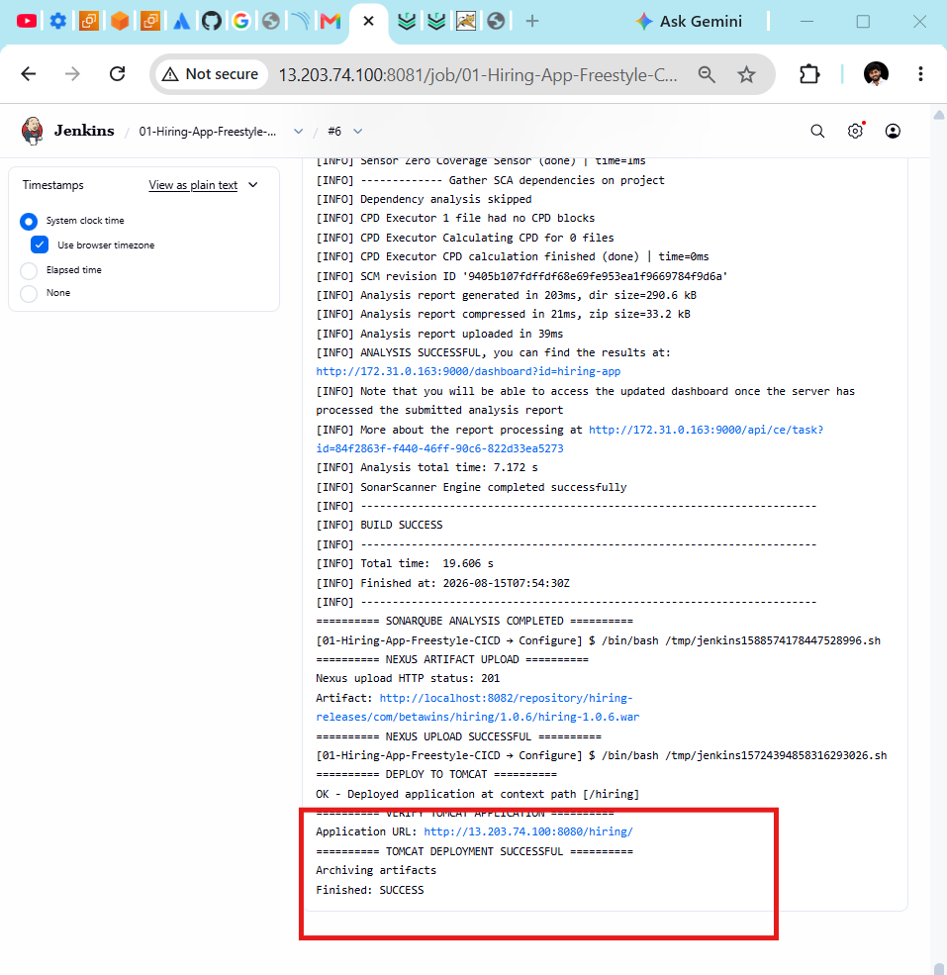

Slack notification
1. Verify the Slack app
In Slack, open #jenkins-alerts and invite the Jenkins bot: /invite @Jenkins
Your custom Slack app should have these bot scopes:
- channels:read
- chat:write
- chat:write.customize
If scopes were recently changed, click Reinstall to Workspace and update the Jenkins token credential if Slack issued a new token.

2. Configure Slack globally in Jenkins
- Go to: Manage Jenkins → System → Slack
- Configure:
- Workspace: your Slack workspace subdomain
- Credential: Slack Jenkins bot token
- Default channel/member ID: #jenkins-alerts
- Custom slack app bot user: Enabled
- Override URL: Leave empty
For example, if the workspace URL is: https://mydevopsworkspace.slack.com
enter only: mydevopsworkspace
Click Test Connection.
Expected: Success
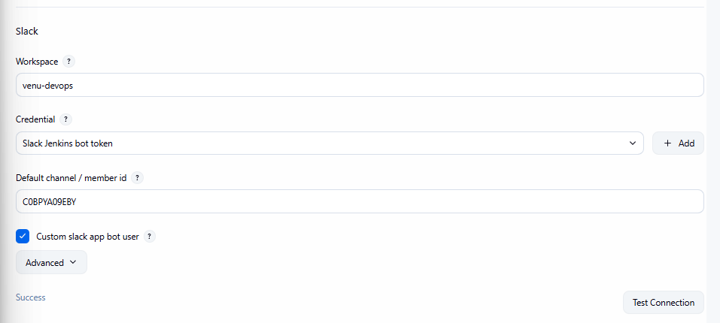

The Custom slack app bot user option is important because you created a custom Slack app with a Bot User OAuth token, as described in the official Jenkins Slack plugin instructions.

3. Add notifications to the Freestyle job
Open: 01-Hiring-App-Freestyle-CICD → Configure
Under Post-build Actions, click: Add post-build action → Slack Notifications
Enable:
Notify Success
Notify Failure
Notify Unstable
Notify Aborted
Notify Back To Normal
Include Test Summary
Include Custom Message
Set:
Project Channel: #jenkins-alerts
Custom Message: Hiring App CI/CD | Job: $JOB_NAME | Build: #$BUILD_NUMBER | Status: $BUILD_STATUS | $BUILD_URL
Keep Archive the artifacts as the other post-build action.
Save and run Build Now. A successful end-to-end run should send a Slack message after the Tomcat deployment.
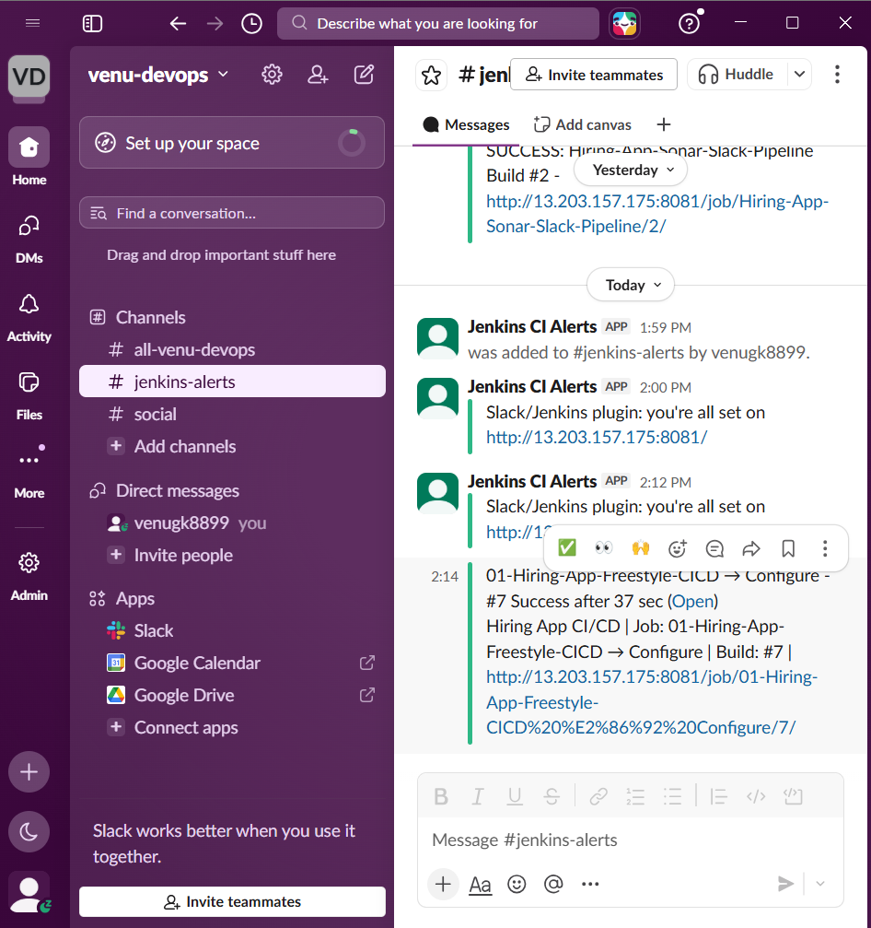

Task 2: Declarative Pipeline
Repository: https://github.com/betawins/sabear_simplecutomerapp.git
Branch: feature-1.1
Step 1: Verify the repository and Maven artifact
Connect to the Jenkins server and run:
- mkdir -p /home/ec2-user/task2-test
- cd /home/ec2-user/task2-test
Clone only the required branch:
- git clone \
--branch feature-1.1 \
--single-branch \
https://github.com/betawins/sabear_simplecutomerapp.git
Enter the repository: cd sabear_simplecutomerapp
Verify:
- git branch --show-current
- find . -maxdepth 2 \( -name "pom.xml" -o -name "Dockerfile" -o -name "Jenkinsfile" \)
- Test the Maven build in Docker:
- mkdir -p .m2
- docker run --rm \
-v "$PWD:/workspace" \
-v "$PWD/.m2:/root/.m2" \
-w /workspace \
maven:3.9-eclipse-temurin-17 \
mvn clean package -DskipTests
- Identify the artifact:
- find . -path "*/target/*" \
\( -name "*.war" -o -name "*.jar" \) \
-type f
Expected branch: feature-1.1
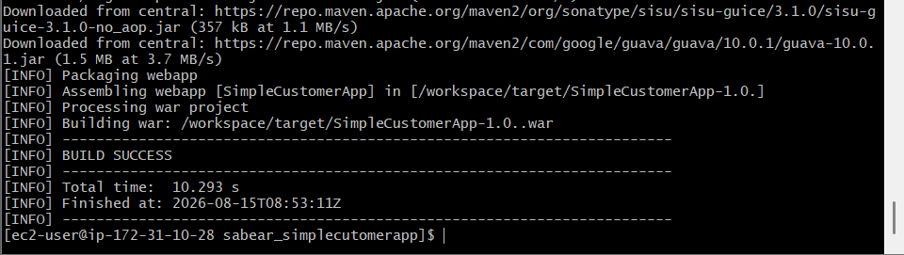

Create the Declarative Pipeline job
In Jenkins: New Item
Name: 02-SimpleCustomerApp-Declarative
Type: Pipeline
Click OK.
Configure:
Description:
Declarative CI/CD Pipeline for SimpleCustomerApp feature-1.1 branch
Enable: Discard old builds
Days to keep: 7
Maximum builds: 10

Open the Jenkins Pipeline job and use:
Definition: Pipeline script
Paste this complete Declarative Pipeline:
- if ! echo "$DEPLOY_RESPONSE" | grep -q '^OK'; then
echo "Tomcat deployment failed"
exit 1
fi

APP_STATUS=$(curl -sS \
-u "${TOMCAT_CREDS_USR}:${TOMCAT_CREDS_PSW}" \
"${TOMCAT_URL}/manager/text/list" \
| grep '^/customerapp:')

echo "Tomcat application status: $APP_STATUS"

if ! echo "$APP_STATUS" | grep -q ':running:'; then
echo "Application is not running"
exit 1
fi

echo "========== TOMCAT DEPLOYMENT SUCCESSFUL =========="
Then click: Save → Build Now
The pipeline will create a separate Tomcat application: http://13.203.74.100:8080/customerapp/
Expected stages:
Git Clone
Prepare Version
Maven Compilation
SonarQube Integration
Nexus Artifactory
Deploy On Tomcat
Declarative: Post Actions
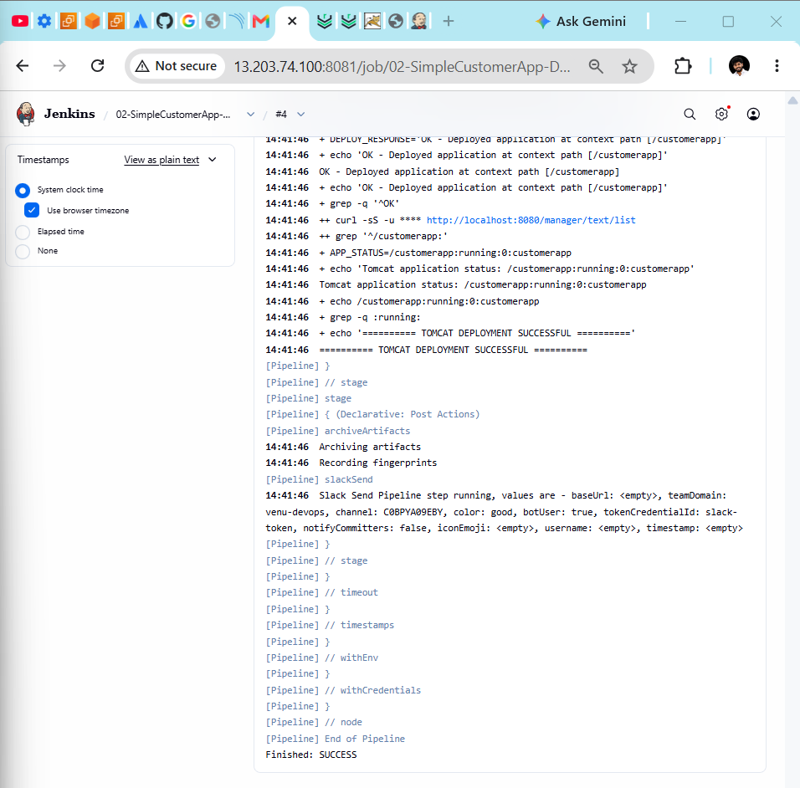

Slack Notification:
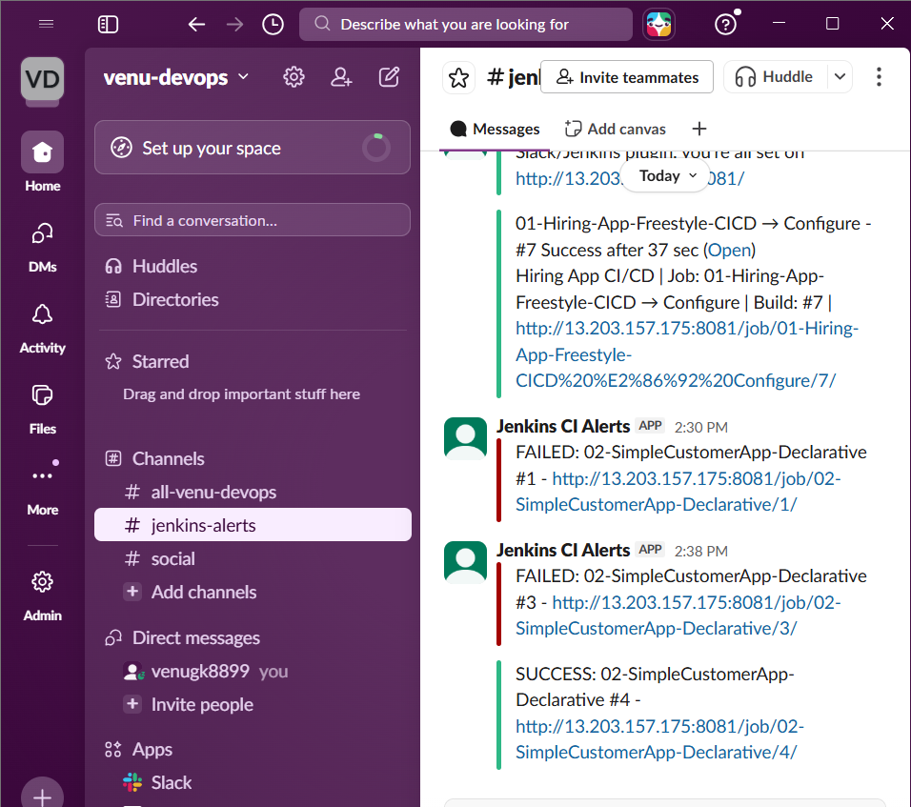

Task 3: Scripted Pipeline
Create: New Item
Name: 03-SimpleCustomerApp-Scripted
Type: Pipeline
Under Pipeline, select:
Definition: Pipeline script
Paste this complete Scripted Pipeline:
- node {
WAR_FILE=$(cat .war-file)

DEPLOY_RESPONSE=$(curl -sS \
-u "${TOMCAT_USER}:${TOMCAT_PASSWORD}" \
--upload-file "$WAR_FILE" \
"${TOMCAT_URL}/manager/text/deploy?path=/customerapp-scripted&update=true")

echo "$DEPLOY_RESPONSE"

if ! echo "$DEPLOY_RESPONSE" | grep -q '^OK'; then
echo "Tomcat deployment failed"
exit 1
fi

APP_STATUS=$(curl -sS \
-u "${TOMCAT_USER}:${TOMCAT_PASSWORD}" \
"${TOMCAT_URL}/manager/text/list" \
| grep '^/customerapp-scripted:')

echo "Tomcat application status: $APP_STATUS"

if ! echo "$APP_STATUS" | grep -q ':running:'; then
echo "Application is not running"
exit 1
fi

echo "========== TOMCAT DEPLOYMENT SUCCESSFUL =========="
'''
}

stage('Archive Artifact') {
archiveArtifacts(
artifacts: 'target/*.war',
fingerprint: true
)
}

buildSucceeded = true
currentBuild.result = 'SUCCESS'

} catch (Exception error) {
currentBuild.result = 'FAILURE'
echo "Pipeline failed: ${error}"
throw error

} finally {
stage('Slack Notification') {
if (buildSucceeded) {
slackSend(
channel: 'C0BPYA09EBY',
color: 'good',
message: "SUCCESS: ${env.JOB_NAME} #${env.BUILD_NUMBER} - ${env.BUILD_URL}"
)
} else {
slackSend(
channel: 'C0BPYA09EBY',
color: 'danger',
message: "FAILED: ${env.JOB_NAME} #${env.BUILD_NUMBER} - ${env.BUILD_URL}"
)
}
}
}
}
}
}
}
}
Click: Save → Build Now

Task 3 uses:
- Sonar project: simplecustomerapp-scripted
- Nexus artifact: SimpleCustomerApp-scripted
- Tomcat context: /customerapp-scripted
- Slack channel: #jenkins-alerts
Unlike Declarative Pipeline, this Scripted Pipeline has no pipeline {}, stages {}, steps {} or post {} blocks.
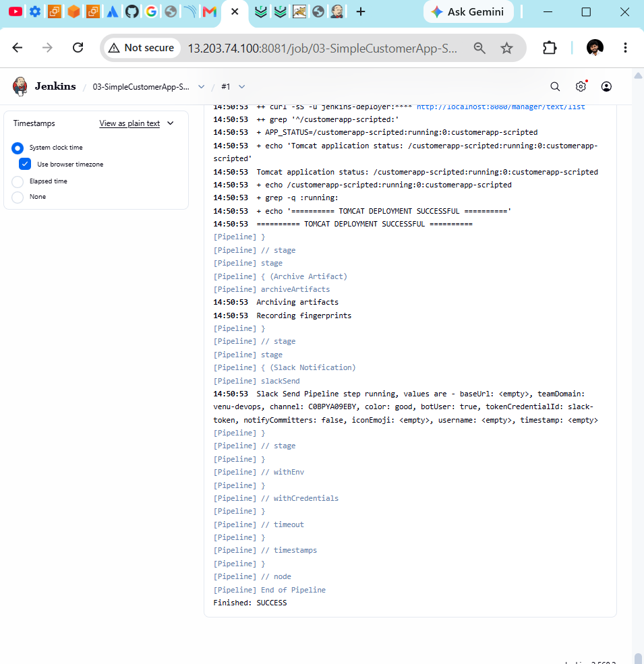
Slack Notification:
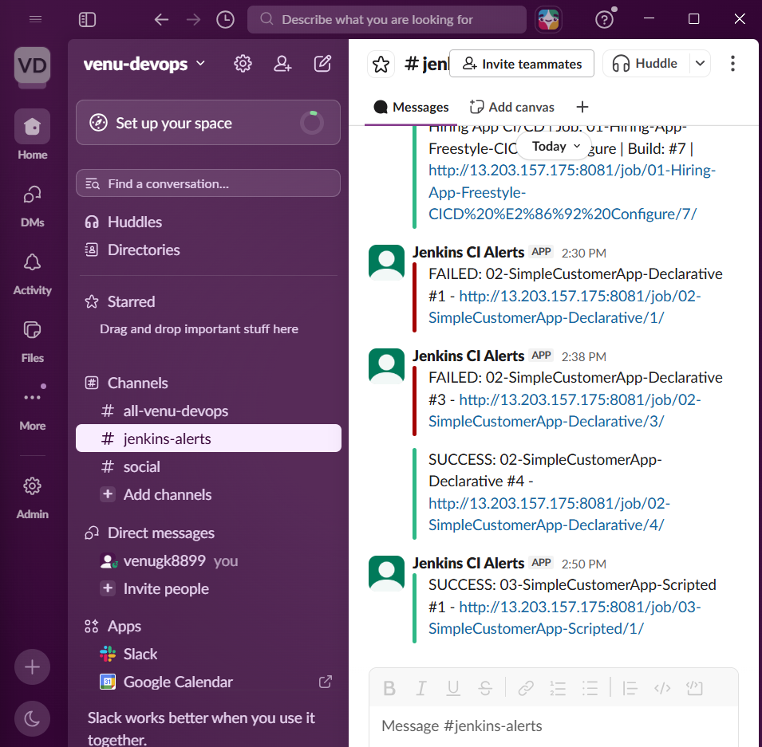
Task 4: Sample pipeline skeletons
We will create two Jenkins jobs:
04A-Declarative-Pipeline-Skeleton
04B-Scripted-Pipeline-Skeleton
These skeletons demonstrate structure only. They don’t need GitHub, SonarQube, Nexus or Tomcat.
Part A: Declarative Pipeline skeleton
Step 1: Create the job
From Jenkins Dashboard:
- Click New Item.
- Enter:
04A-Declarative-Pipeline-Skeleton
- Select Pipeline.
- Click OK.
Step 2: Configure
Description:
Sample skeleton demonstrating Declarative Pipeline syntax.
Under Pipeline:
Definition: Pipeline script
Paste:
pipeline {
agent any

environment {
APP_NAME = 'sample-application'
DEPLOY_ENV = 'dev'
}

stages {
stage('Git Clone') {
steps {
echo "Cloning source code for ${APP_NAME}"
}
}

stage('Build') {
steps {
echo "Building ${APP_NAME}"
}
}

stage('Test') {
steps {
echo "Testing ${APP_NAME}"
}
}

stage('Deploy') {
steps {
echo "Deploying ${APP_NAME} to ${DEPLOY_ENV}"
}
}
}

post {
success {
echo 'Declarative Pipeline completed successfully'
}

failure {
echo 'Declarative Pipeline failed'
}

always {
echo "Final status: ${currentBuild.currentResult}"
}
}
}
Step 3: Run
Click:
Save → Build Now → Console Output
Expected:
Cloning source code
Building
Testing
Deploying
Declarative Pipeline completed successfully
Finished: SUCCESS
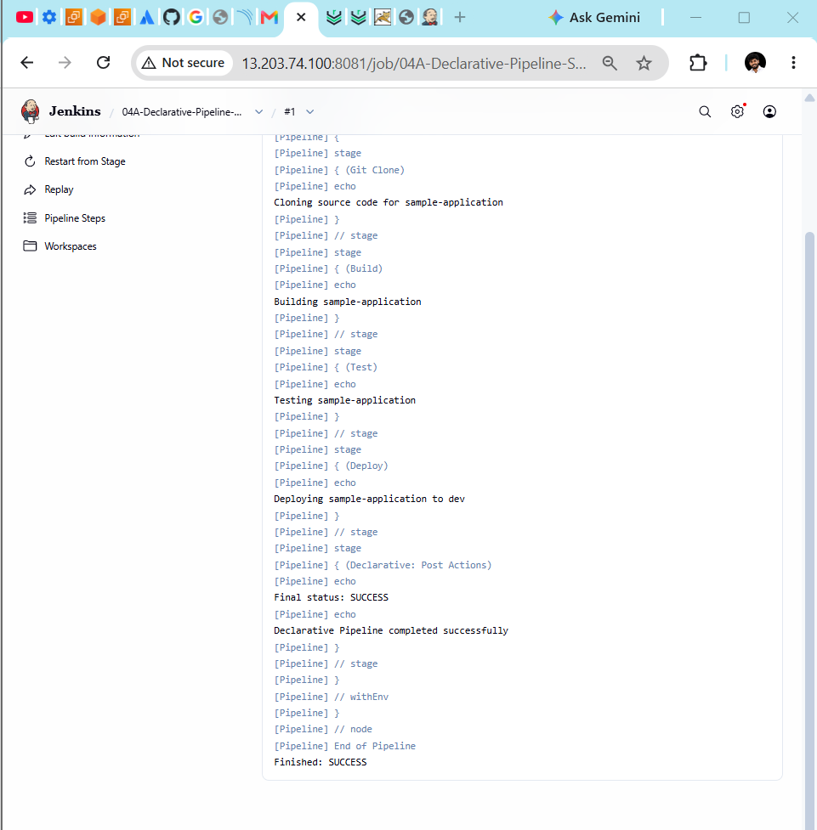
Part B: Scripted Pipeline skeleton
Step 1: Create the job
From Jenkins Dashboard:
- Click New Item.
- Enter:
04B-Scripted-Pipeline-Skeleton
- Select Pipeline.
- Click OK.
Step 2: Configure
Description:
Sample skeleton demonstrating Scripted Pipeline syntax.
Under Pipeline:
Definition: Pipeline script
Paste:
node {
def appName = 'sample-application'
def deployEnvironment = 'dev'

try {
stage('Git Clone') {
echo "Cloning source code for ${appName}"
}

stage('Build') {
echo "Building ${appName}"
}

stage('Test') {
echo "Testing ${appName}"
}

stage('Deploy') {
echo "Deploying ${appName} to ${deployEnvironment}"
}

currentBuild.result = 'SUCCESS'

} catch (Exception error) {
currentBuild.result = 'FAILURE'
echo "Pipeline error: ${error}"
throw error

} finally {
stage('Notification') {
echo "Final status: ${currentBuild.currentResult}"
}
}
}
Step 3: Run
Click:
Save → Build Now → Console Output
Expected:
Cloning source code
Building
Testing
Deploying
Final status: SUCCESS
Finished: SUCCESS
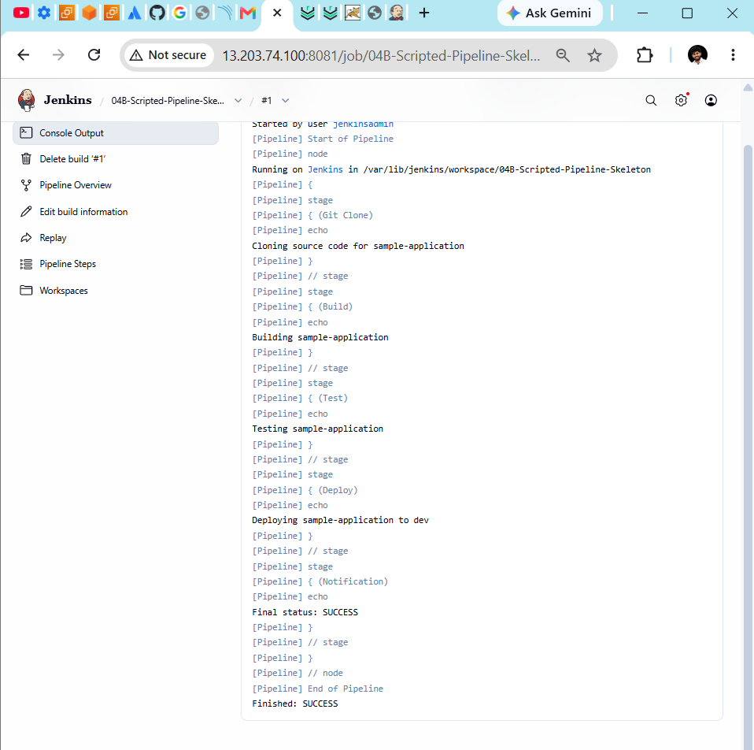
Declarative versus Scripted
Declarative | Scripted
Starts with pipeline {} | Usually starts with node {}
Uses stages, stage, steps | Uses stage directly
Uses post for final actions | Uses try, catch, finally
Easier to read and validate | More flexible Groovy logic
Recommended for most pipelines | Useful for complex workflows

Task 5: Parameterized Jenkins job
Repository:
https://github.com/betawins/spring3-mvc-maven-xml-hello-world-1.git
Step 1: Check the default branch
On Jenkins01, run:
git ls-remote --symref \
https://github.com/betawins/spring3-mvc-maven-xml-hello-world-1.git \
HEAD
Look for:
ref: refs/heads/main
or:
ref: refs/heads/master
Use that branch as the default value below.
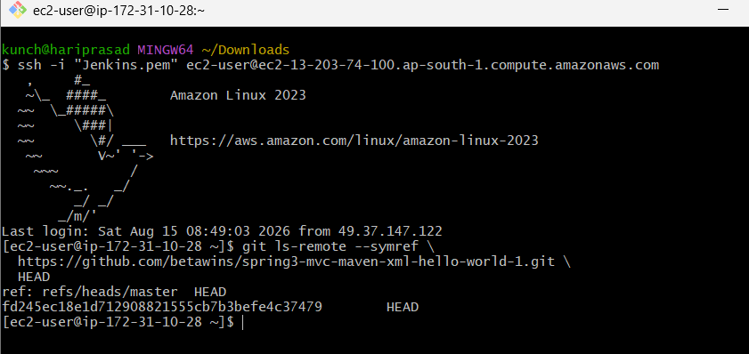
Step 2: Create the job
From Jenkins Dashboard:
New Item
Enter:
05-Spring3-MVC-Parameterized-Job
Select:
Freestyle project
Click OK.
Step 3: General configuration
Description:
Parameterized Maven build job for Spring3 MVC application.
Enable:
This project is parameterised
Add these parameters.
String parameter
Name: GIT_BRANCH
Default value: main
Description: Git branch to build
Use master instead if Step 1 reports master.
Choice parameter
Name: MAVEN_GOAL
Choices:
clean package
clean test
clean install
Description: Maven goal to execute
Boolean parameter
Name: SKIP_TESTS
Default: Enabled
Description: Skip Maven tests during the build
Choice parameter
Name: DEPLOY_ENV
Choices:
dev
qa
uat
prod
Description: Target environment for this build
Step 4: Configure Git
Under Source Code Management → Git:
Repository URL:
https://github.com/betawins/spring3-mvc-maven-xml-hello-world-1.git

Credentials:
None

Branch Specifier:
*/$GIT_BRANCH
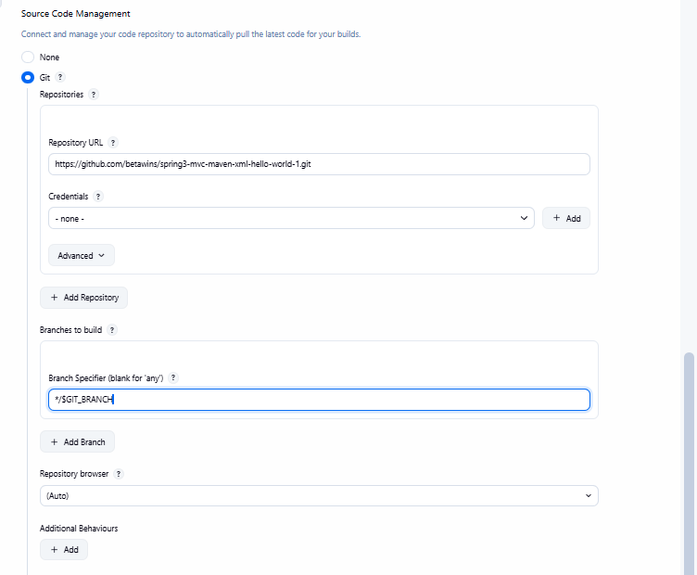
Step 5: Add Docker Maven build
Under Build Steps → Execute shell, paste:
#!/bin/bash
set -e

echo "========== PARAMETER VALUES =========="
echo "Git branch: $GIT_BRANCH"
echo "Maven goal: $MAVEN_GOAL"
echo "Skip tests: $SKIP_TESTS"
echo "Environment: $DEPLOY_ENV"

mkdir -p "$WORKSPACE/.m2"

MAVEN_OPTIONS=""

if [ "$SKIP_TESTS" = "true" ]; then
MAVEN_OPTIONS="-DskipTests"
fi

echo "========== MAVEN BUILD =========="

docker run --rm \
--user "$(id -u):$(id -g)" \
-e HOME=/tmp \
-v "$WORKSPACE:/workspace" \
-v "$WORKSPACE/.m2:/tmp/.m2" \
-w /workspace \
maven:3.8.8-eclipse-temurin-8 \
mvn \
-Dmaven.repo.local=/tmp/.m2/repository \
$MAVEN_GOAL \
$MAVEN_OPTIONS
echo "========== GENERATED ARTIFACTS =========="

find target -maxdepth 1 \
\( -name "*.war" -o -name "*.jar" \) \
-type f \
-ls

echo "Build completed for environment: $DEPLOY_ENV"
Step 6: Archive the artifact
Under Post-build Actions → Archive the artifacts:
target/*.war,target/*.jar
Enable:
Archive artifacts only if build is successful
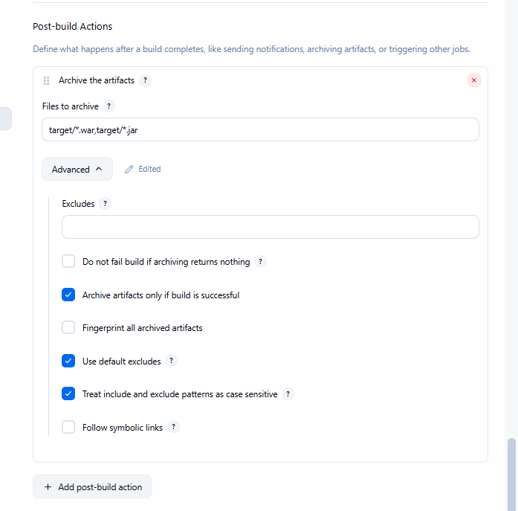
Step 7: Run with parameters
Click:
Save → Build with Parameters
First test:
GIT_BRANCH: repository default branch
MAVEN_GOAL: clean package
SKIP_TESTS: enabled
DEPLOY_ENV: dev
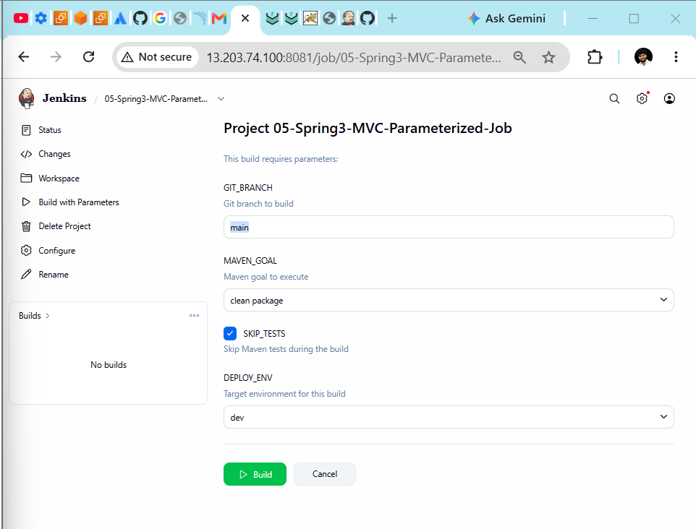
Then click Build and verify Finished: SUCCESS.
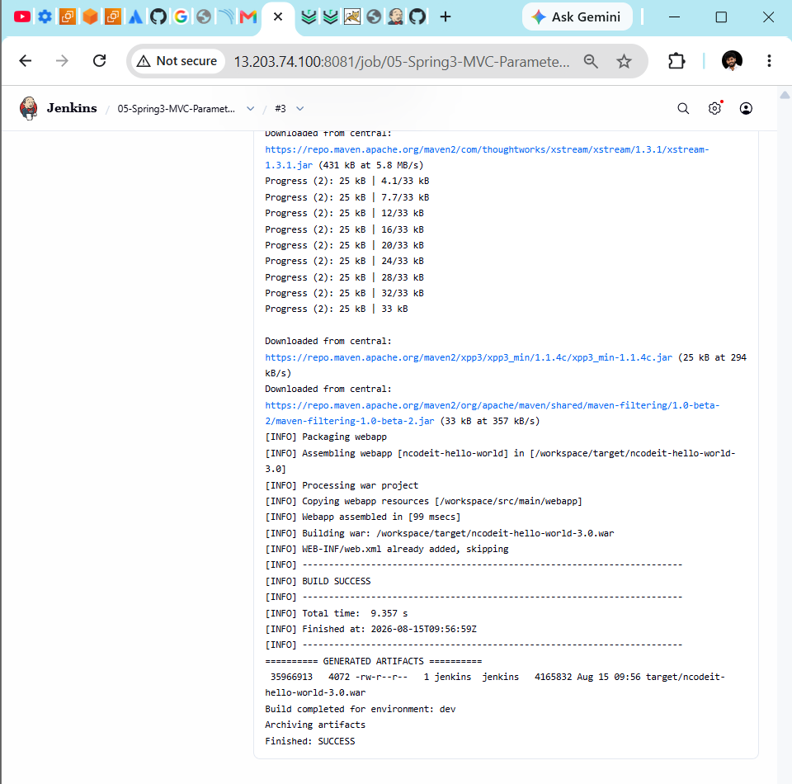

Task 6: Configure one Jenkins agent
Task 6: Jenkins agent setup — changes completed
1. Started the agent EC2 instance
Existing instance:
Name: Jenkins-Agent01
Instance ID: i-0a12047d81e754eee
Instance type: t3.small
Private IP: 172.31.3.131
VPC: vpc-009cec8ac07410e5d
The instance was initially stopped. We started it and waited for SSH to become available.
2. Verified the agent security group
Security group:
Jenkins-Agent-SG
Confirmed inbound SSH:
Protocol: TCP
Port: 22
Source: Jenkins controller security group
Description: SSH from Jenkins controller
This allows Jenkins01 at 172.31.10.28 to connect to the agent securely through its private IP.
3. Used the existing Jenkins SSH credential
Credential:
Credential ID: jenkins-agent-ssh-key
SSH username: ec2-user
Jenkins successfully authenticated:
SSH Authentication successful
4. Configured the Jenkins node
Node settings:
Node name: Jenkins-Agent01
Host: 172.31.3.131
Remote root directory: /home/ec2-user/jenkins
Launch method: Launch agents via SSH
Credentials: jenkins-agent-ssh-key
Executors: 1
Recommended labels:
devops docker-maven-agent
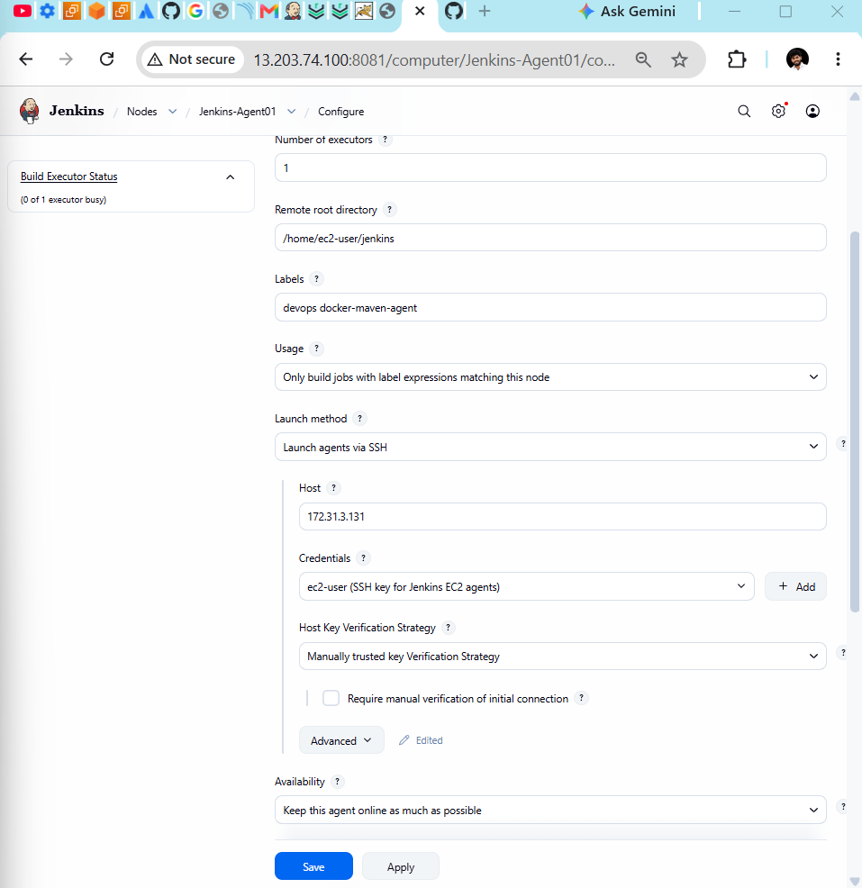
5. Verified Java and the remote directory
Jenkins executed:
cd /home/ec2-user/jenkins
java -jar remoting.jar
The remote work directory was initialized at:
/home/ec2-user/jenkins/remoting
This confirms Java was already installed and working.
6. Verified Jenkins Remoting
Jenkins checked and reused the existing agent file:
Verified agent jar
No update is necessary
Remoting version: 3355.3357.v931d3c992987
7. Agent connected successfully
Final status:
Channel started
Launcher: SSHLauncher
This is a Unix agent
Agent successfully connected and online
The earlier errors:
No route to host
Connection refused
occurred only while the EC2 instance and SSH service were starting.
8. Final test job
Create or run:
Job: 06-Jenkins-Agent-Verification
Label: docker-maven-agent
The Console Output must show:
Building remotely on Jenkins-Agent01
User: ec2-user
Java version displayed
Git version displayed
Finished: SUCCESS
